Lab 6 – Implementing VoIP

# Overview

In this lab, we will be using Cisco's Packet Tracer software. This simulator tool is used to model network components that we will talk about in the context of security, such as devices, routers, switches, and others.

This lab must be completed with all work being done and written as it is done into Word 365 Online. Use the Lab Book Template and upload to your Word 365 Online and begin working there.

Also note the requirement for the packet tracer file to be submitted, as well as your initials and last 4 digits of your student number to be present in the names of the objects you create in packet tracer during this lab. Not meeting this requirement (including the submission of the packet tracer file you use to create the objects in this lab) will result in a zero as well..

Preparation

You will need:

• Current version of Packet tracer

• 3 x PC PT Objects

• 1 x Cisco 2960 Layer 2 Switch

• 1 x Cisco 2811 Router

• 3 x IP Phones

Description

* In your own words, provide a description of the expected goals and results as you understand them.

Part 1 – Building the Topology

You will initially build out and configure your network topology as per lab schematic Figure 1-1. Completing this section will result in a topology that will be ready to configure.

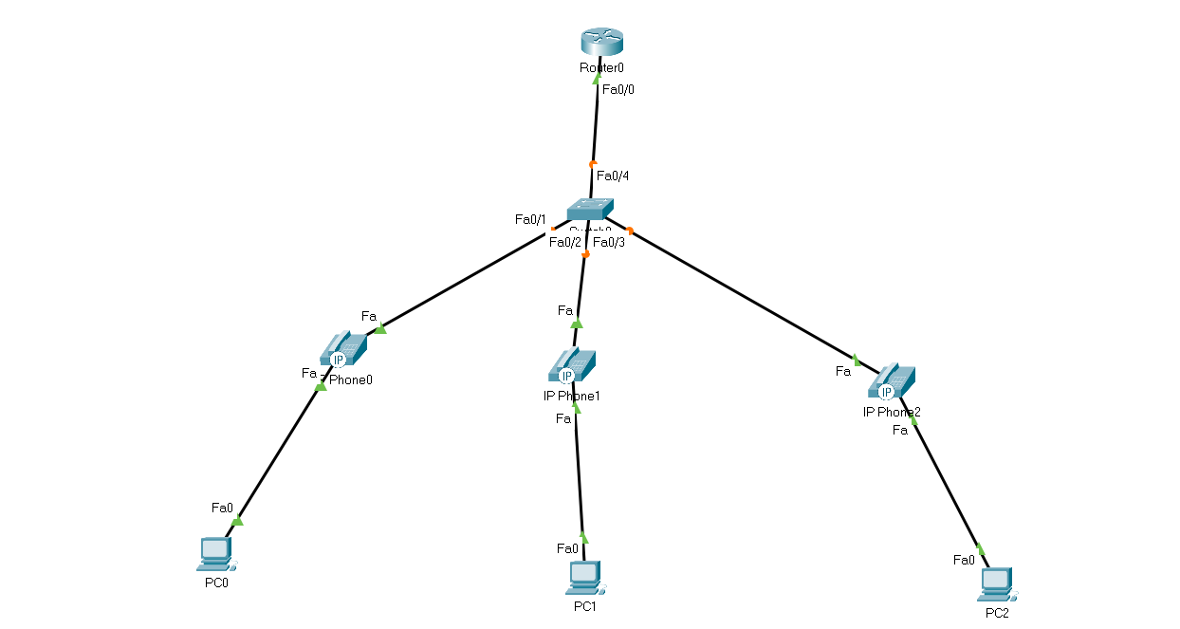

Fig:1-1

Part 2 – Configuring the Topology

* Start by configuring the network devices router, switch and IP phones

Screenshots

* Include screenshots of each step successfully connecting to each of the IP Phones and the switch

Observations and Reflection

* Write down your observations and reflections including details on any problems encountered or solved.

Wrap Up

* Make sure you save and backup your configuration.